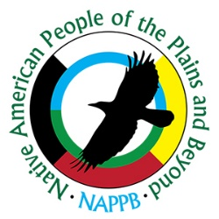
FOOD VENDOR APPLICATION
Native American People of the Plains and Beyond
1st Annual “Old Time Gathering” Intertribal Powwow
November 21, 2026
Lubbock Fair Park Coliseum
801-899 Avenue A, Lubbock, TX 79403

To apply for more than one space, photocopy this application and fill out the information for each space separately. EACH APPLICATION must be accompanied by a $50.00 Cashier Check or Money Order. No personal checks accepted. Vendor set up Friday November 20, 2026, or Saturday Morning November 21, 2026. Tear down Sunday November 22, 2026.

Signature agreeing to payment: _______________________________________________________

Contact Information (please write legibly)
Name
Business Name
Street Address
City, State, Zip
Phone & Cell
E-mail Address (mandatory)
Website
Taxpayer ID (mandatory)
Food Service License | Attach copy with application

Costs:
Food Vendor Space | $ 50.00
Amount Enclosed | $
Set-Up; Electricity, Water | ACCESS AVAILABLE

Your company and website will be added to our website at https//www.nappbtexas.org

We hope you have an enjoyable and profitable experience with the Native American People of the Plains and Beyond Powwow Event, and that you will consider joining us again next year.

Send application and payment by cashier check or money order to:

Native American People of the Plains and Beyond
9823 CR 5400Shallowater, TX 79363

